**Cloud Architecture Flowchart for ETL Solution using GCP Tools**

**Below is a step-by-step description of the proposed ETL solution architecture using GCP tools:**

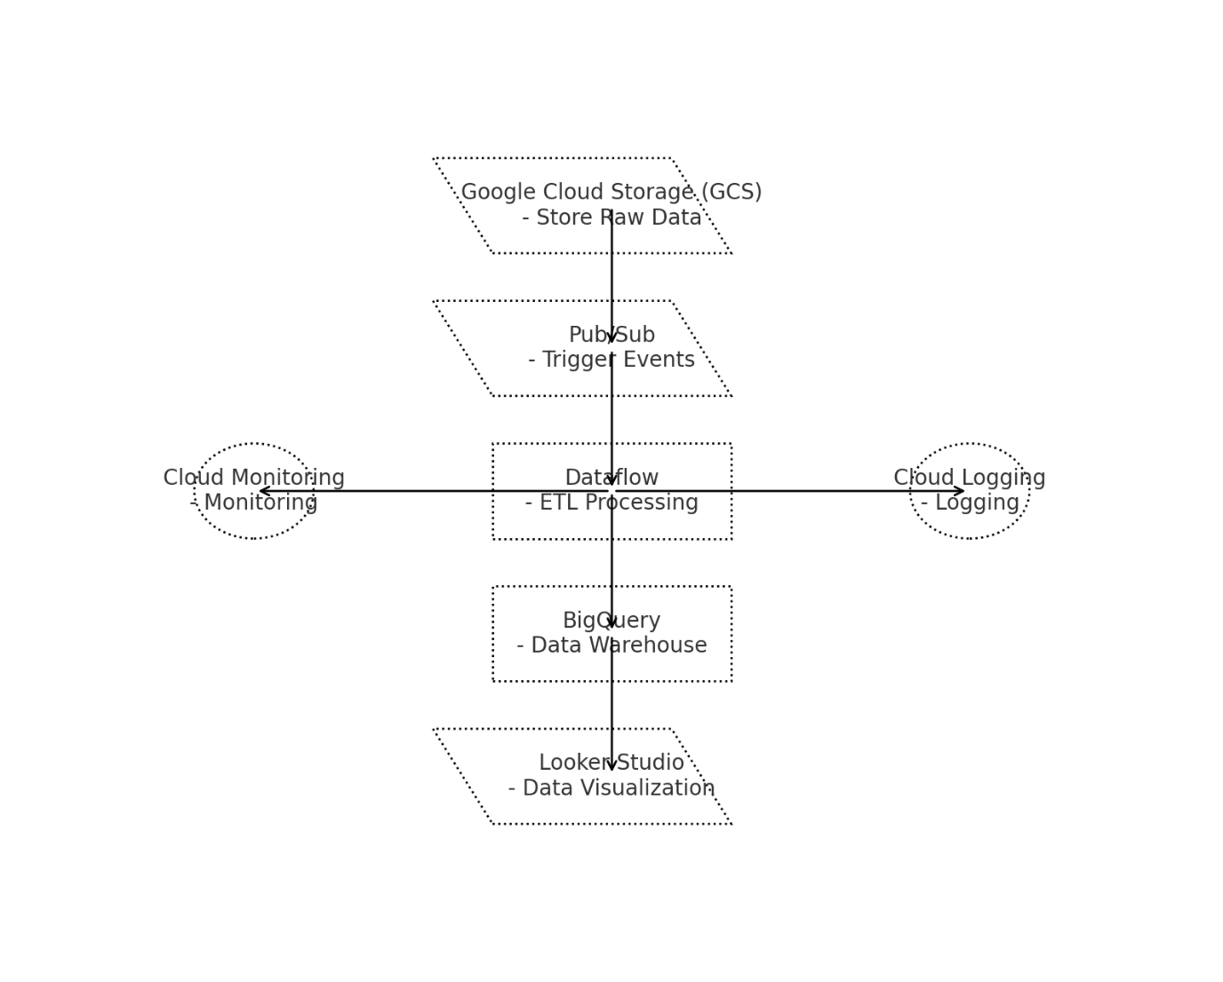

**1. Data Extraction (GCS + Pub/Sub)**

* **Google Cloud Storage (GCS):**
  + **Purpose: Stores raw data files (e.g., CSV, JSON, Parquet) uploaded from various sources like Kaggle.**
  + **Rationale: GCS is a cost-effective, scalable, and highly available storage service suitable for storing large datasets.**
* **Pub/Sub:**
  + **Purpose: Acts as a message broker to trigger events when new files are uploaded to GCS.**
  + **Rationale: Pub/Sub provides a reliable, asynchronous messaging system that can notify downstream services (like Dataflow) about file uploads in real-time.**

**2. Data Processing (Dataflow)**

* **Google Dataflow:**
  + **Purpose: Handles the core ETL processing, including:**
    - **Extraction: Reads data from GCS.**
    - **Cleansing/Validation: Applies transformations, such as data cleansing, deduplication, and validation.**
    - **Transformation: Transforms raw data into structured formats suitable for analysis.**
  + **Rationale: Dataflow is a fully managed, serverless stream and batch data processing service based on Apache Beam. It provides scalability, flexibility, and ease of integration with other GCP services.**

**3. Data Loading (BigQuery)**

* **BigQuery:**
  + **Purpose: Serves as the data warehouse where transformed data is loaded for analytics and reporting.**
  + **Rationale: BigQuery is a fully managed, serverless data warehouse that enables fast SQL queries using the processing power of Google's infrastructure. It supports real-time analytics and large-scale data processing.**

**4. Data Visualization (Looker Studio)**

* **Looker Studio (formerly Data Studio):**
  + **Purpose: Provides data visualization and reporting capabilities.**
  + **Rationale: Looker Studio is a user-friendly tool for creating interactive dashboards and reports. It directly integrates with BigQuery to fetch and display analytics in real-time.**

**5. Monitoring and Management (Cloud Monitoring + Logging)**

* **Cloud Monitoring:**
  + **Purpose: Tracks the performance, uptime, and overall health of the ETL pipeline, including resource usage and latency.**
  + **Rationale: Cloud Monitoring provides observability into your application and infrastructure performance, ensuring reliability and quick identification of issues.**
* **Cloud Logging:**
  + **Purpose: Collects logs from all GCP services involved in the pipeline, such as GCS, Dataflow, and BigQuery.**
  + **Rationale: Cloud Logging allows centralized log management, which is crucial for debugging, auditing, and compliance purposes.**

**Detailed Flowchart Description**

1. **Data Source:**
   * **Kaggle/Other Sources upload data files to GCS.**
2. **GCS Triggers Pub/Sub:**
   * **When a new file is uploaded, Pub/Sub sends a notification to the Dataflow pipeline.**
3. **Dataflow Pipeline:**
   * **Listens to Pub/Sub messages.**
   * **Reads the uploaded file from GCS.**
   * **Cleanses, validates, and transforms the data.**
   * **Writes the processed data to BigQuery.**
4. **BigQuery:**
   * **Stores the transformed data for analysis.**
   * **Provides SQL-based querying for analytics.**
5. **Looker Studio:**
   * **Connects to BigQuery to create visual dashboards and reports for business insights.**
6. **Monitoring and Logging:**
   * **Cloud Monitoring and Cloud Logging provide real-time insights and logs for the ETL pipeline’s performance and operations.**

**Diagram Key Components**

* **GCS (Google Cloud Storage): Raw Data Storage**
* **Pub/Sub: Event-driven triggers for file uploads**
* **Dataflow: ETL pipeline for processing and transformation**
* **BigQuery: Data warehouse for structured data**
* **Looker Studio: Visualization and reporting tool**
* **Cloud Monitoring & Logging: Observability and logging services**

**Conclusion**

**This architecture ensures a fully automated, scalable, and efficient ETL process using GCP tools, from data ingestion to visualization. Each tool is chosen for its ability to handle specific tasks efficiently, ensuring that the entire data pipeline is streamlined, reliable, and easily manageable.**